1. Using Eclipse download the following plugins
a. Builship Gradle integration 3.0
b. Eclipse Java EE Developer Tools 3.12
c. Eclipse JST Server Adapters (Apache Tomcat, Jon..
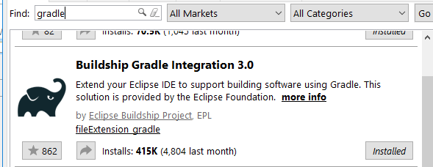
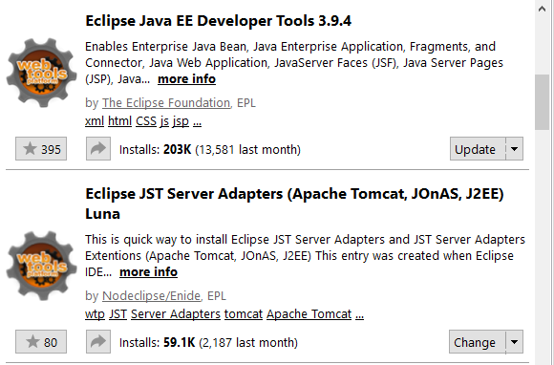

- Make sure that Eclipse can run Java Web projects. If not sure, go to Help ->Install New Software. Select a site and download
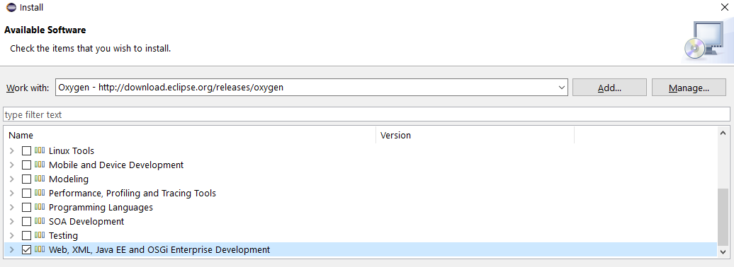

- On the web browser - download Tomcat 8.0
a. Install it onto your java JRE folder
b. (If u cant see Tomcat)
i. Window preferences on Eclipse -> Search Tomcat -> config the server -> select version 8.5 -> server location, other fields will be automatically filled
4. Importing Scentaur
a. File -> Import -> Gradle -> Existing Gradle Project -> Scentaur
b. Accept everything
5. Right click Scentaur -> Gradle -> refresh gradle
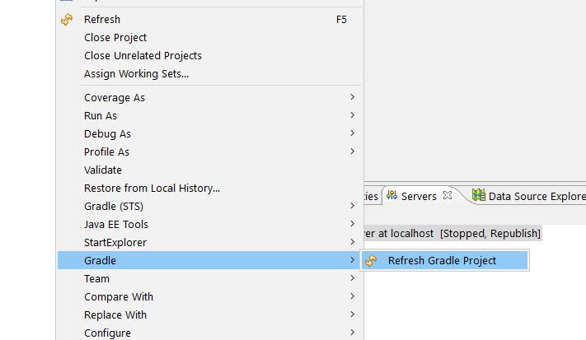
- Right click Scentaur -> Properties -> Java Build Path -> Configure Build Path -> Libraries-> Add JARs -> Scentaur -> WebContent -> WEB-INF -> lib -> Everything -> Apply
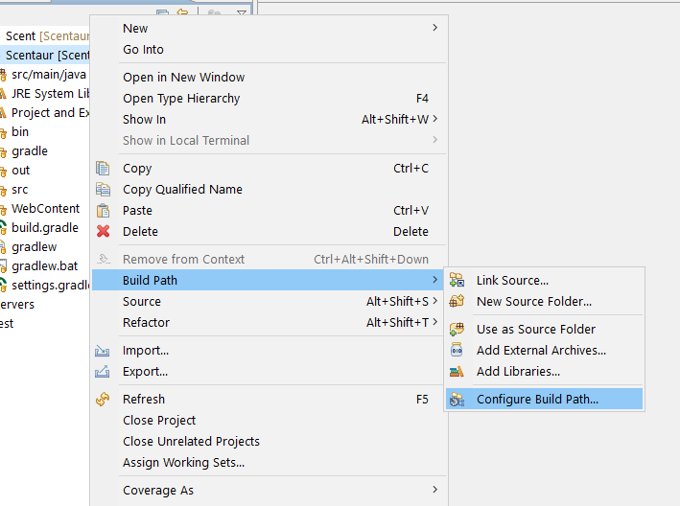
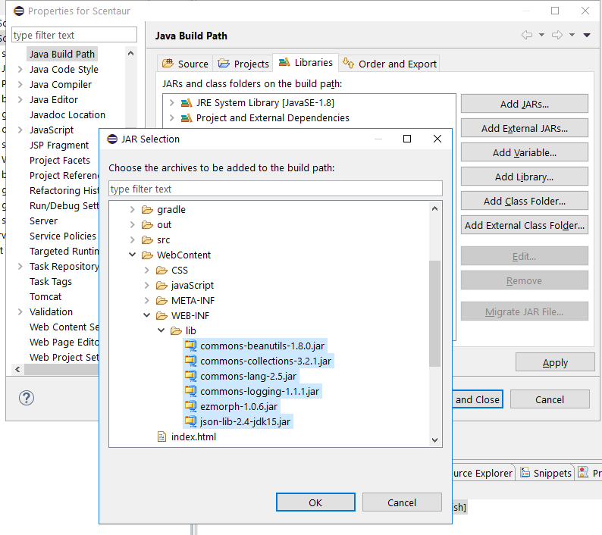
- Right Click Scentaur -> Properties -> Deployment Assembly -> Add -> Java Build Path Entries -> Select Everything -> Finish -> Apply
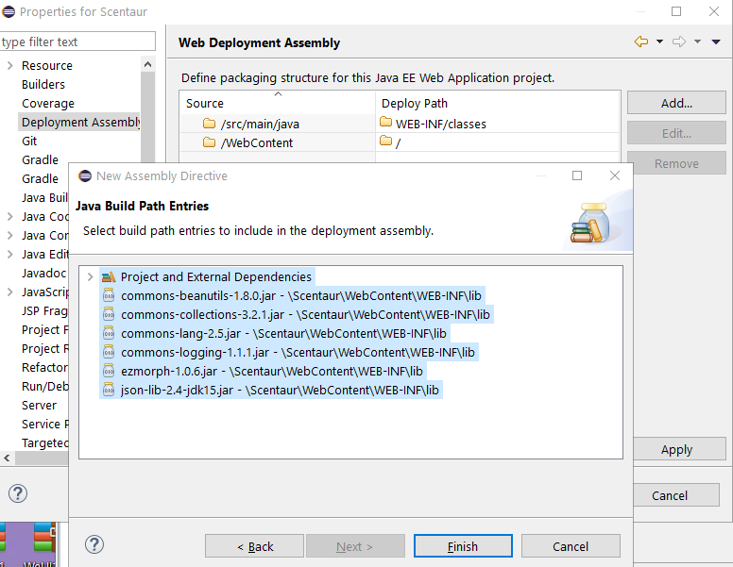

- Right Click Scentaur -> Properties -> Project Facets, make sure Dynamic Web Module is ticked, and Tomcat v8.5 is applied in Runtimes.
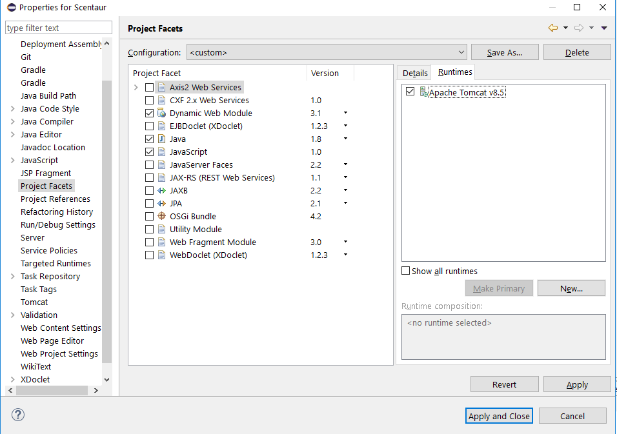

- Right click Scentaur -> Run as -> Run on Server, select Tomcat v8.5 Server at localhost -> finish
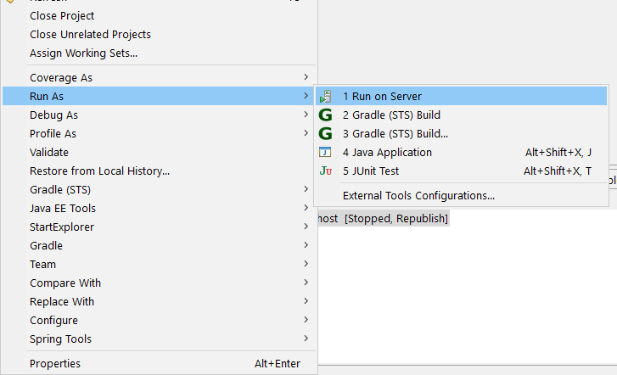
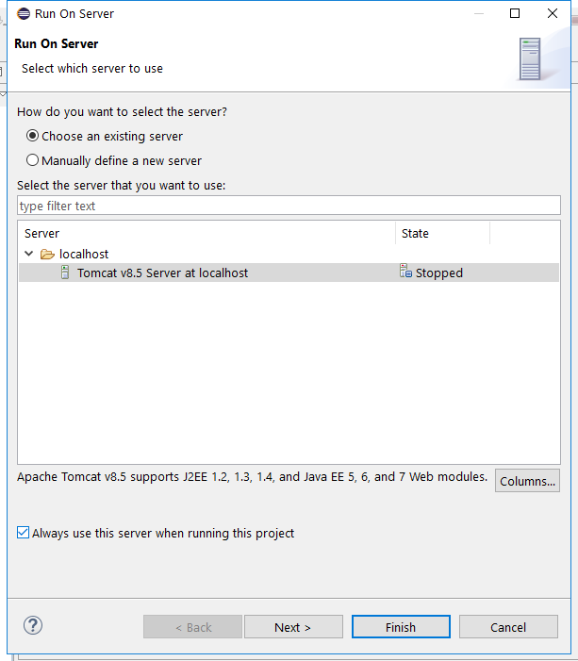

- Refreshing Gradle will remove all the external dependencies in the build path and on the server. Make sure you configure the build path again(Step 6) and go to Deployment Assembly to deploy all the external dependencies on to the server(Step 7) each time after you refresh Gradle.

